Linux Environment Variable Assignment

- State the command for the following.
  - view current environment variables
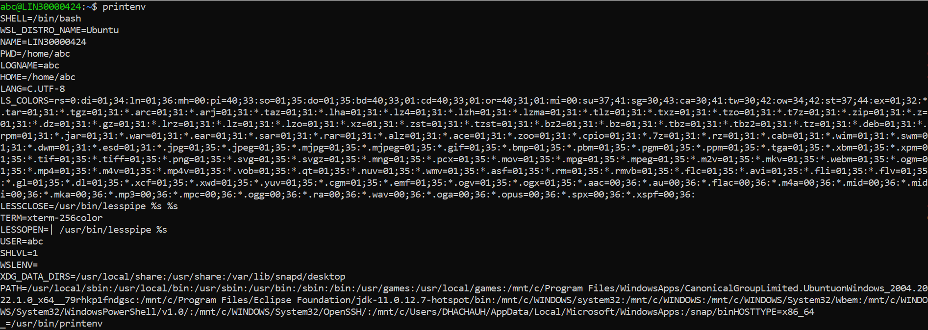
  - display the PATH evirnment variable value
  - update PATH to include the path to your home directory.
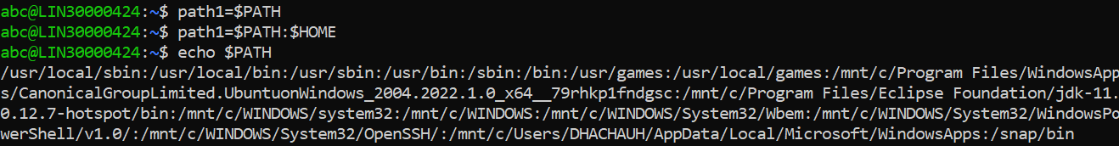
- How will you make the environment changes applicable to all users? Which script is to be modified?
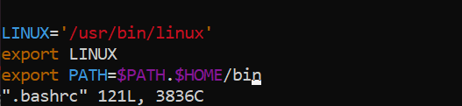
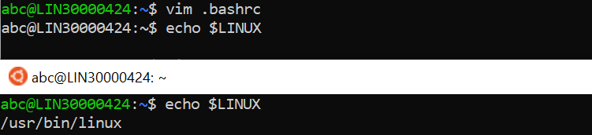
To declare the global variable in environemt we have to declare var in “.bashrc”

- I have installed an application named “myapp”. After installation, if I invoke the application, it fails with error as “Command myapp not found”. How will you fix this?

Ans: In order to fix the error “Command myapp not found” in ubuntu, few steps can be used for resolving this errors:
- Making sure command is user’s path.
- Adding a new path to add new directory or the package “myapp”.
- Copying a file to existing path whenever the package is to be installed.

